Borrower: Angel Hongye (Cambodia) Investment Co., Ltd

Shareholder: Mdm Zhou Kaiying and Mdm Luy Theary

1. Angel Hongye (Cambodia) Investment Co., Ltd (Reg. No. 00013844)

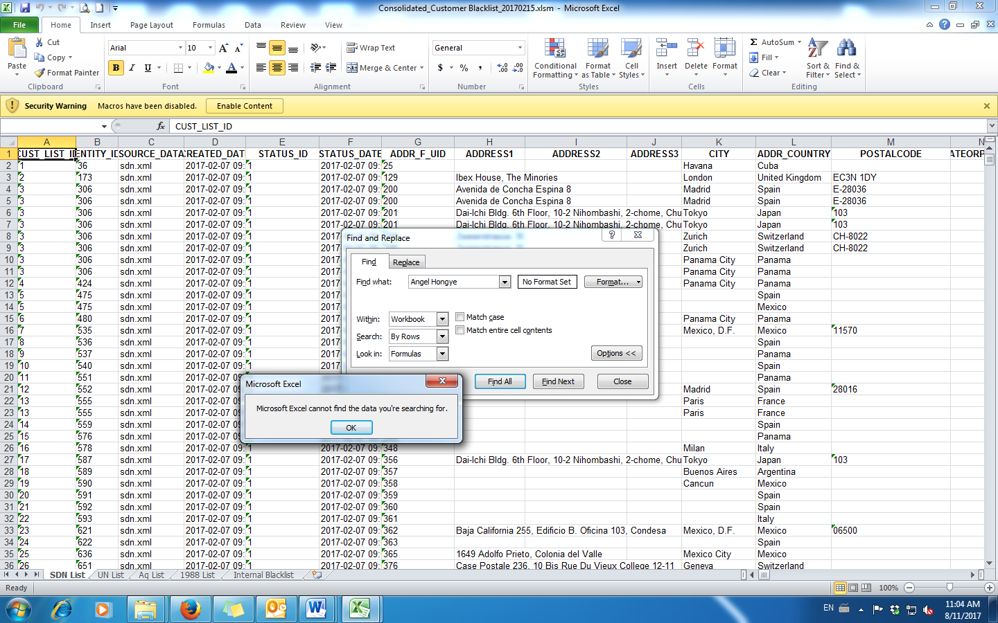

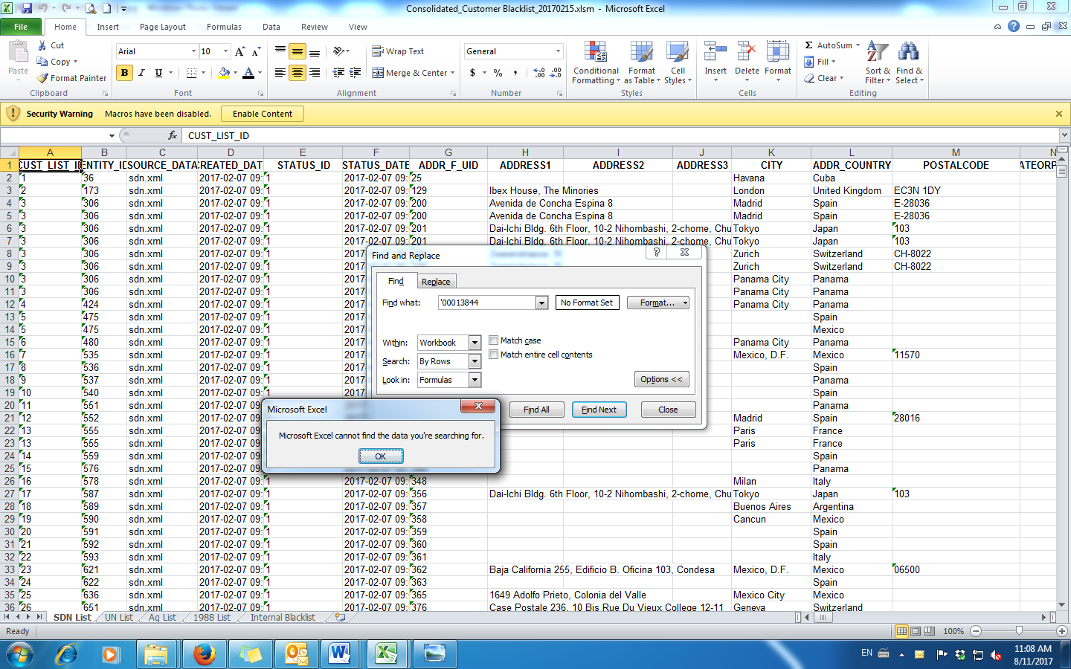

1. Mdm. Zhou Kaiying (Passport No. E08567634)

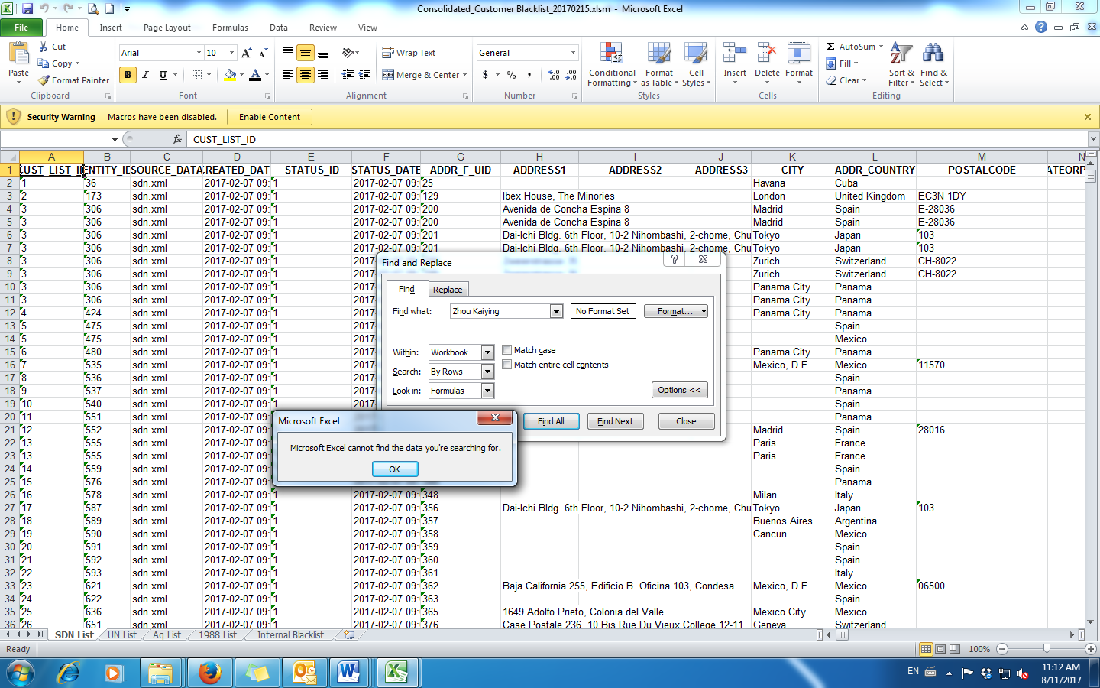

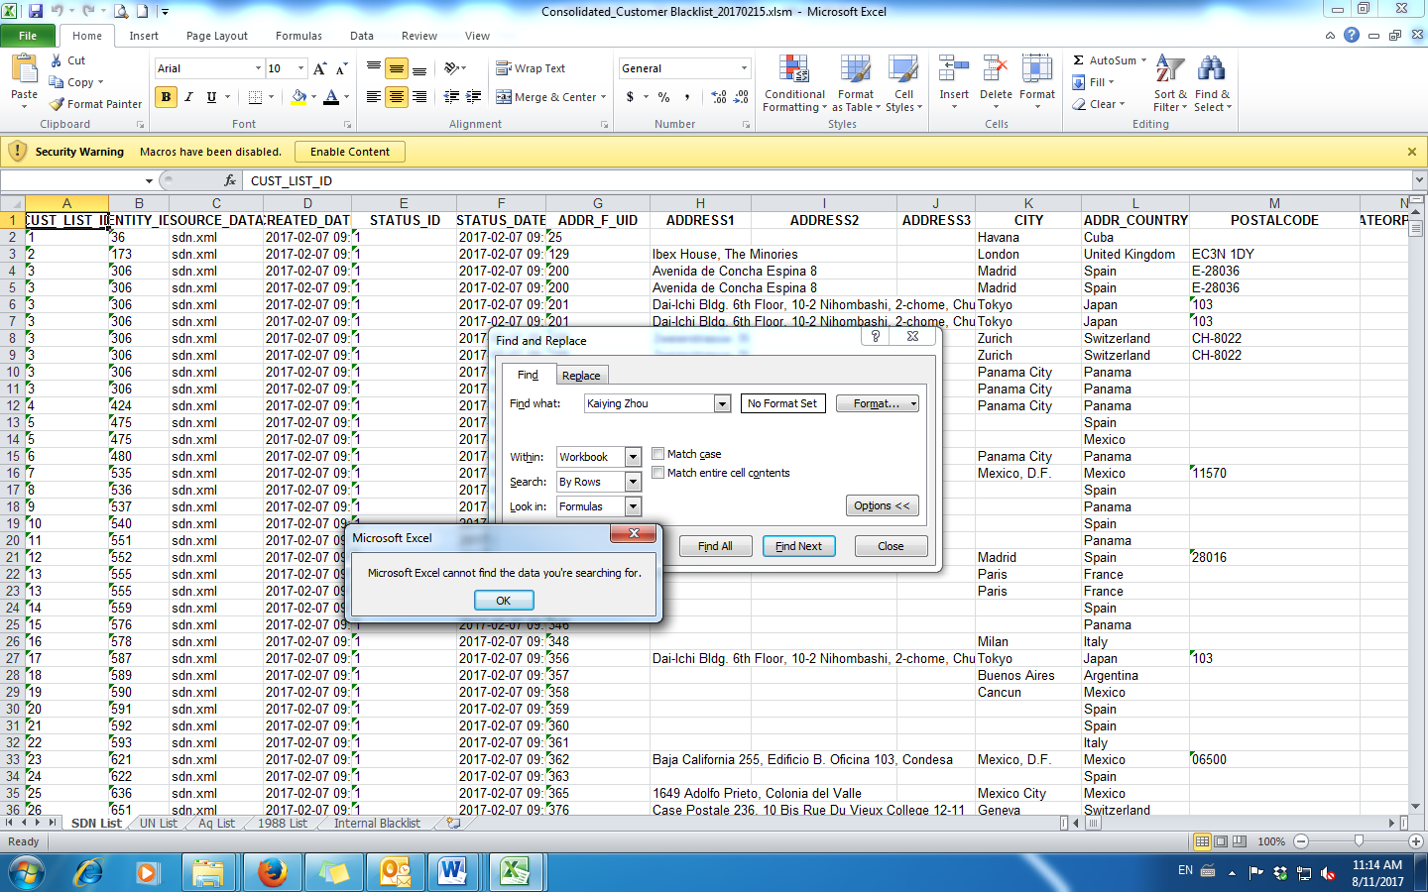

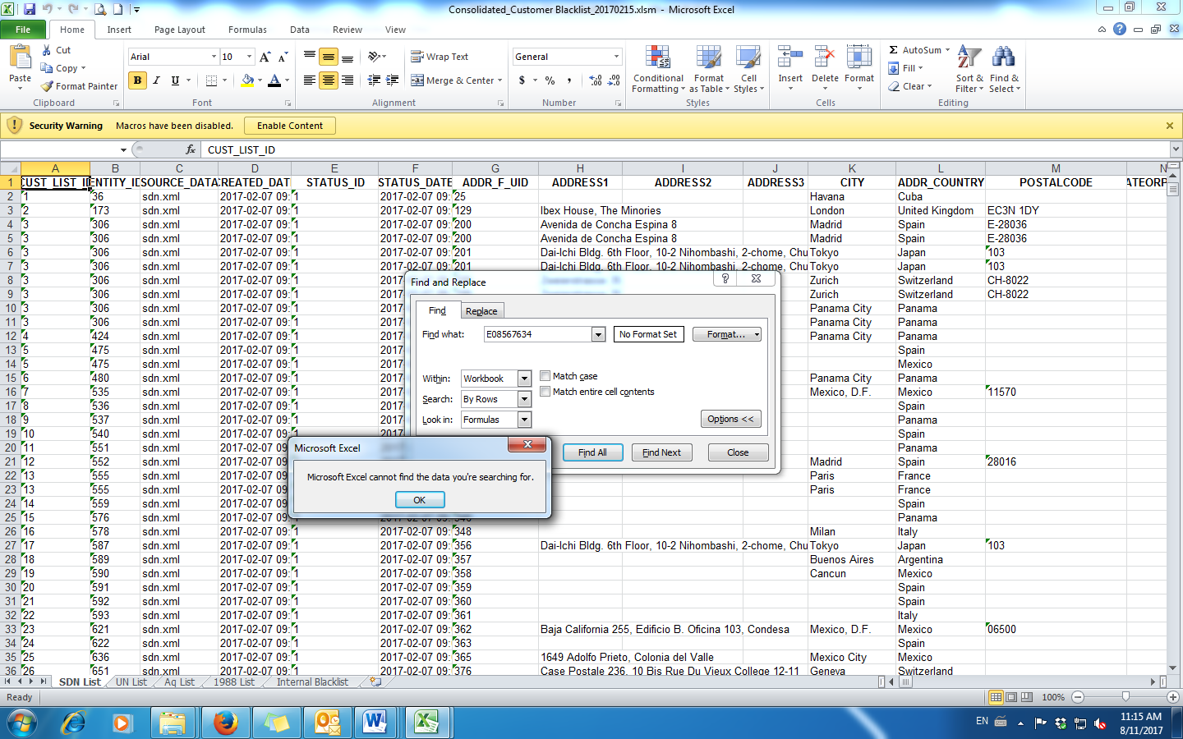

1. Mdm. Luy Theary (ID No. 180667457)

